**GREEN SKILLS & AI INTERNSHIP**

**Weekly Milestone – Week 1**

Create account in LMS and login

Select the project title and download the offer letter

Project tittle : Exhaustive Analysis of Indian Agriculture sector using Power BI

Downlaod the data set from LMS

In Power BI I am learned a basic detail about the how to import the data and handling the data

Key steps : ETL

E – Extract – Extract or import the different type of data from database and local disk ,

T – Transform – In this step used to Cleaning the data and data processing ,

L – Load – Load the data for analysis .

**Step 1**

Downoad the Power BI tool in windows

Learned about the basic concept from the mentor like how to import data, clean the data ,and

Views in Power BI

**Step 2**

**Importing data**

Import the data set to Power BI

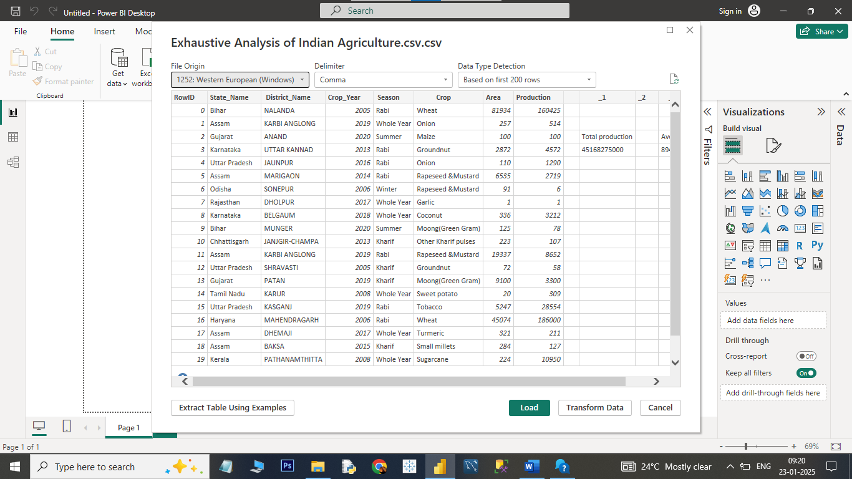

**Step – 3**

**Transform**

Transform the data to Power Query for clening the data and data processing

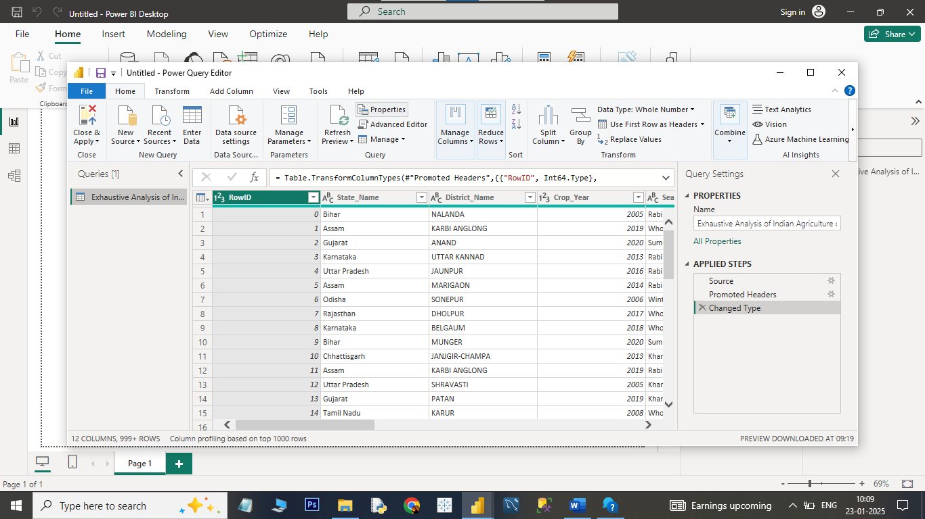

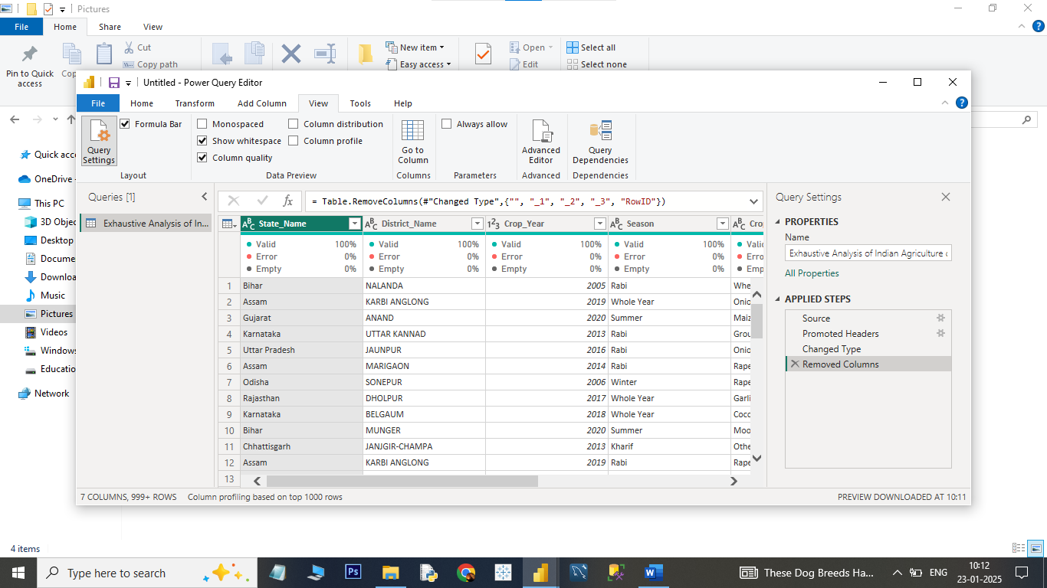

**Step – 3**

**Load**

Loading the data from Power Query to Power BI Dashboard for analysis the data

